Ideation Phase
Empathize & Discover
Date | 01-10-2026 | Team ID | SWTID-2026-5415
Project Name | Import Data Using Transform Maps (Spreadsheet) | Maximum Marks | 4 Marks
The primary user is a ServiceNow administrator or authorized project user who prepares, imports, verifies and secures spreadsheet-based records.
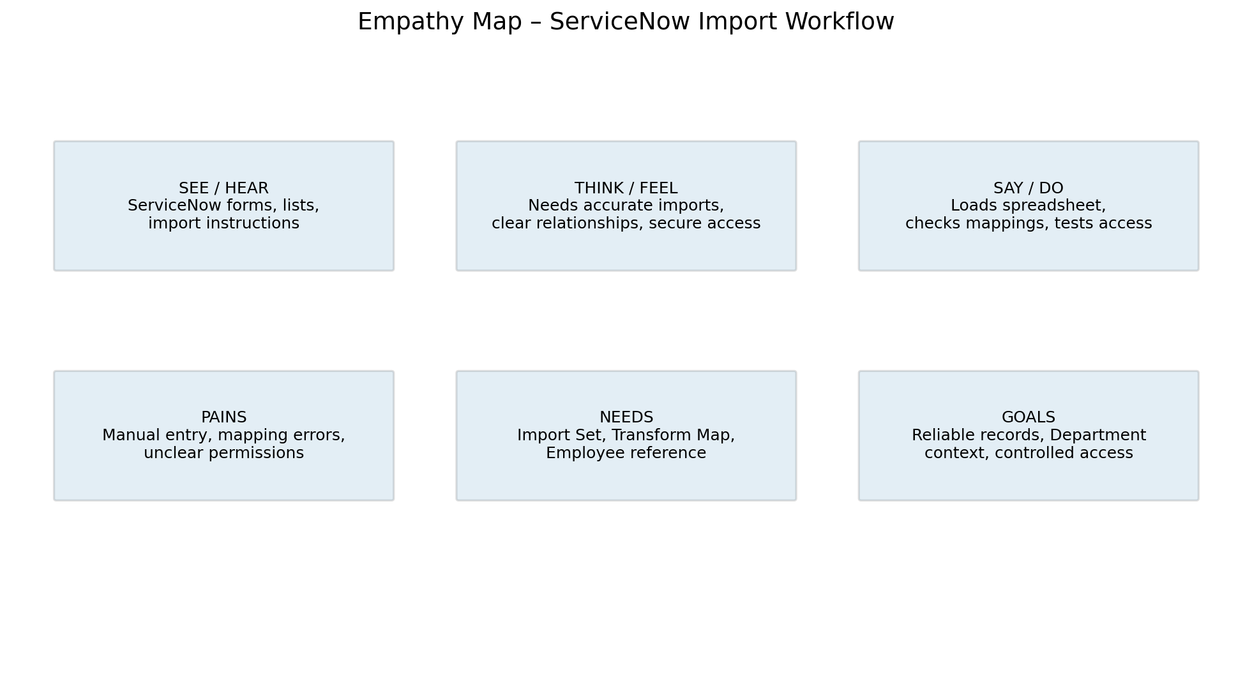
Empathy Area | Project Understanding
Says | I need the spreadsheet to load correctly and the transformed records to be easy to verify.
Thinks | The field mapping must be correct and access should be controlled.
Does | Prepares spreadsheet, loads data, configures Transform Map, checks Employee/Department and tests access.
Feels | Wants confidence that the imported data is accurate and secure.
Pains | Mapping mistakes, missing references and unclear permissions.
Needs | Import Set, Transform Map, Employee reference, dot-walking, roles and ACLs.

